
CSA15 Cloud Computing and Big Data Analytics
CO1 AT2 - Digital Concept Map and Service Model Matrix
Individual Student Submission Template

Student and Faculty Details
Student Name | VALLAPU MOHANKUMAR | Register Number | 192524225
Class / Section |  | Slot | C
Course Code | CSA1517 | Course Title | Cloud Computing In Big Data Analytics
Capstone Title | FoodTrace Cloud Supply Chain Tracker with QR Provenance and Spoilage Prediction
Submission Date | 16/07/2026
Faculty Name | Dr. Rajesh Babu .c | Employee ID
Department | B Tech (AI&DS)

Assessment Brief
Course Outcome | CO1 - Explain the evolution, architecture, characteristics, service models, and emerging paradigms of cloud computing.
Assessment Type | Individual concept mapping, service-model responsibility analysis, and capstone-cloud interpretation.
Assessment Focus | Each map must show key nodes, link labels, relationship meaning, and a logical hierarchy. The response must connect cloud fundamentals to the student's own perception of the capstone title.
Submission Mode | Editable DOCX + exported diagram evidence + GitHub repository link submitted in Google Classroom.
Permitted Tools | draw.io / diagrams.net, Lucidchart, Miro, Canva, PowerPoint, Google Drawings, or equivalent diagramming tool.
Individual Rule | Every student must submit their own concept map, matrix, capstone-cloud mapping, and reflection. The capstone title may be shared by a team, but the assessment answer must not be common.
Total Marks | 100 marks

Code of Conduct and Student Assurance
Academic Integrity Statement
This assessment must be completed individually. Students may discuss the capstone domain with their team, but the concept map, service model matrix, explanations, GitHub evidence, and reflection submitted here must be individually prepared.
Student Assurance | I confirm that this submission represents my own understanding of CO1 concepts and my individual interpretation of the selected capstone title.
Tool Use | I have used digital tools only for diagram preparation, organization, and presentation. I have not copied another student's diagram, matrix, or explanation.
Evidence | I have uploaded the required files to my GitHub repository and submitted the repository link / evidence link through Google Classroom.
Student Signature | V. Mohan Kumar
Date | 16/07/2026

Procedure for Preparing the Digital Concept Map
Use the following procedure to prepare the diagram and upload evidence. Students who already know another diagramming tool may use it, but the exported evidence and source file must still be submitted.
- Open https://app.diagrams.net/ or the desktop version of draw.io / diagrams.net.
- Choose Device, Google Drive, or OneDrive as the save location according to availability.
- Create a blank diagram and name the file as CSA15_CO1_AT2_RegisterNumber_Concept_Map.drawio.
- Place the capstone title at the center or as a clearly visible anchor node.
- Add major cloud nodes: cloud definition, cloud evolution, cloud architecture, service models, deployment models, virtualization, web services, SOAP, REST, APIs, elasticity, scalability, resource pooling, measured service, and emerging paradigms.
- Connect nodes with labeled arrows such as uses, depends on, enables, scales through, communicates through, belongs to, supports, provides, consumes, or controls.
- Use colors meaningfully: one color for service models, one for cloud characteristics, one for API/web-service concepts, and one for capstone-specific elements.
- Export the final diagram as PNG or PDF. Keep the editable .drawio source file also.
- Paste the exported diagram image or screenshot in this DOCX under Task 1.
- Upload the DOCX, exported PNG/PDF, and .drawio file to GitHub, then submit the GitHub link in Google Classroom.

GitHub Submission Procedure
Step | Required Action | Expected Evidence
1 | Create or use your individual GitHub account. | GitHub profile link.
2 | Create a repository named CSA15-CO-Assessments-RegisterNumber or use the repository instructed by faculty. | Repository URL.
3 | Create a folder named CO1_AT2 inside the repository. | Folder visible in repository.
4 | Upload this completed DOCX, exported diagram PNG/PDF, and editable .drawio source file. | At least three evidence files uploaded.
5 | Add a short README.md explaining the capstone title and files submitted. | README visible in the AT2 folder.
6 | Submit the GitHub folder link in Google Classroom. | GCR submission with repository/folder link.

Assessment Questions and Student Response Sections
Important
The capstone project may be developed by a team, but every response below must be written from the individual student's own perspective. Do not submit a common team answer.

Task 1 - Digital Cloud Concept Map
Create one integrated digital concept map for CO1. The map must show key nodes, link labels, relationship meaning, and a logical hierarchy. It must also connect the concepts to your selected capstone title from your individual perspective.
Mandatory Concept Group | Minimum Concepts / Nodes to Include
Cloud Fundamentals | Definition, characteristics, benefits, limitations, on-demand access, measured service.
Cloud Evolution and Drivers | Hardware evolution, internet software evolution, distributed systems, cost economics, mobility, remote access, big data growth.
Architecture and Deployment | Front-end, back-end, network layer, data center, management software, public/private/hybrid/community cloud.
Service Models and Responsibility | IaaS, PaaS, SaaS, XaaS, provider responsibility, user responsibility, shared responsibility.
Virtualization and Web/API Layer | Virtual machine, hypervisor, abstraction, resource pooling, multi-tenancy, web services, SOAP, REST, API request/response.
Capstone Connection | Your capstone users, app/module, cloud backend, database/storage, dashboard/analytics, scalability and elasticity idea.
Paste exported concept map image / screenshot here. Resize neatly within this white space.

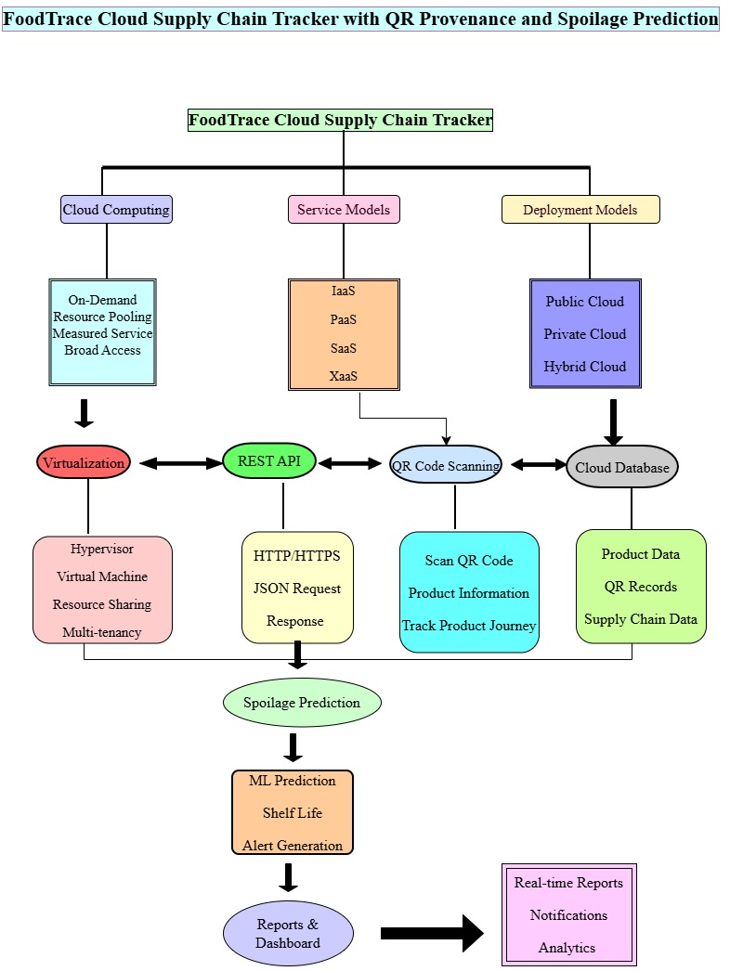

Brief explanation of your concept map: explain the most important nodes, link labels, hierarchy, and capstone connection.
The concept map explains how Cloud Computing supports the FoodTrace Cloud Supply Chain Tracker with QR Provenance and Spoilage Prediction project. The main node is the capstone title, which is connected to Cloud Computing, Service Models, and Deployment Models. Cloud Computing provides on-demand access and resource pooling, while IaaS, PaaS, SaaS, and XaaS support infrastructure, application development, software delivery, and cloud services. REST APIs connect the application to the Cloud Database, where product details and QR records are stored. QR code scanning retrieves product information, and the Spoilage Prediction module analyzes freshness using cloud resources. Finally, the system generates Reports and Dashboard for real-time monitoring and decision-making. The hierarchy starts from the capstone title, flows through cloud technologies, and ends with the final application output, showing how cloud computing enables a scalable and efficient food traceability system.

Task 2 - Service Model Matrix
Complete the matrices by making technical decisions for your capstone project. Select only the rows that are relevant to your capstone design. If a row is not used, write a short technical reason instead of leaving it blank.
Your answer should show how responsibility shifts between cloud provider and student development team, and how the chosen services support the capstone workflow, API design, storage, security, scalability, and evidence submission.

Task 2A - Service Model Responsibility Matrix
Service Model | Capstone Role / Module | Provider Responsibility | Student Responsibility | Evidence to Submit
IaaS | Virtual Server & Storage | Provides virtual machines, storage, and networking | Configure and manage cloud resources | Cloud setup screenshot
PaaS | Application Development | Provides runtime, database, and development platform | Develop and deploy the application | Source code and deployment screenshot
SaaS | FoodTrace Web/Mobile App | Hosts and maintains the application | Manage users and application features | Application screenshot
XaaS / Specialized Service | QR Code & Prediction API | Provides API services | Integrate QR API and prediction service | API testing screenshot

Task 2B - Capstone Cloud Service Decision Matrix
Cloud Layer / Function | Selected Tool or Service | Data / Resource Handled | API or Integration Path | Security / Scaling Note
Client access and UI | Web/Mobile Application | User Details | REST API | Secure Login
API / backend logic | Python Flask | Product Information | REST API | Auto Scaling
Authentication and identity | Firebase Authentication | User Accounts | Firebase API | Role-Based Access
Database / structured records | Firebase Firestore | Product & QR Data | Cloud API | Encrypted Storage
File / object storage | Firebase Storage | QR Images | Storage API | Secure Backup
Monitoring / logs / usage metrics | Firebase Analytics | Usage Logs | Analytics API | Performance Monitoring
Analytics / reporting output | Dashboard | Reports & Alerts | REST API | Scalable Cloud Service
Technical justification: Explain why the selected cloud service pattern fits your capstone project's users, data, API flow, scalability, and security needs.
The FoodTrace Cloud Supply Chain Tracker uses Firebase cloud services because they provide secure authentication, cloud storage, and real-time database support. REST APIs enable communication between the mobile application, backend, and cloud database. This architecture supports QR code tracking, spoilage prediction, scalability, and secure access while ensuring high performance and reliability for all users.

Task 3 - Capstone Cloud Flow Mapping
Study the sample architecture-flow template below. Redraw it in draw.io / diagrams.net using your own capstone architecture. Replace every generic label with your actual user role, screen, API endpoint, backend logic, cloud storage, analytics output, security control, and scalability or elasticity decision.
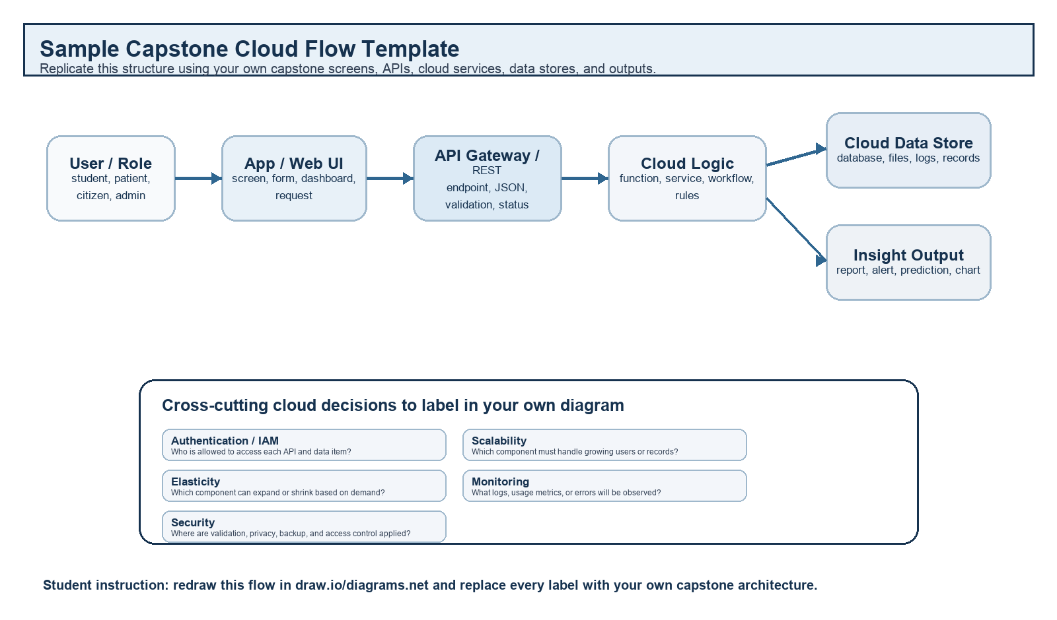
Student Drawing Requirement
Do not copy the sample as it is. Use it as a layout model, then create your own capstone-specific flow diagram with meaningful labels, arrows, data movement, API names, and cloud service choices.
Flow Component | Student Entry
User role and action | Supplier or Customer logs in, adds product details, or scans a QR code.
Frontend / app screen | FoodTrace Web/Mobile Application.
API endpoint and method | REST API (POST – upload product details, GET – retrieve product information).
Backend processing rule | Validates user, processes QR code, predicts spoilage, and updates product records.
Cloud database / storage operation | Stores product details, QR code information, supply chain records, and prediction results in Firebase Cloud Database.
Response, alert, report, or dashboard output | Displays product details, spoilage prediction, notifications, and analytics dashboard.
Security, scalability, and elasticity labels added in diagram | User Authentication, Data Encryption, Auto Scaling, Elastic Resource Allocation, Secure Cloud Storage.
Paste your redrawn capstone cloud-flow diagram here.

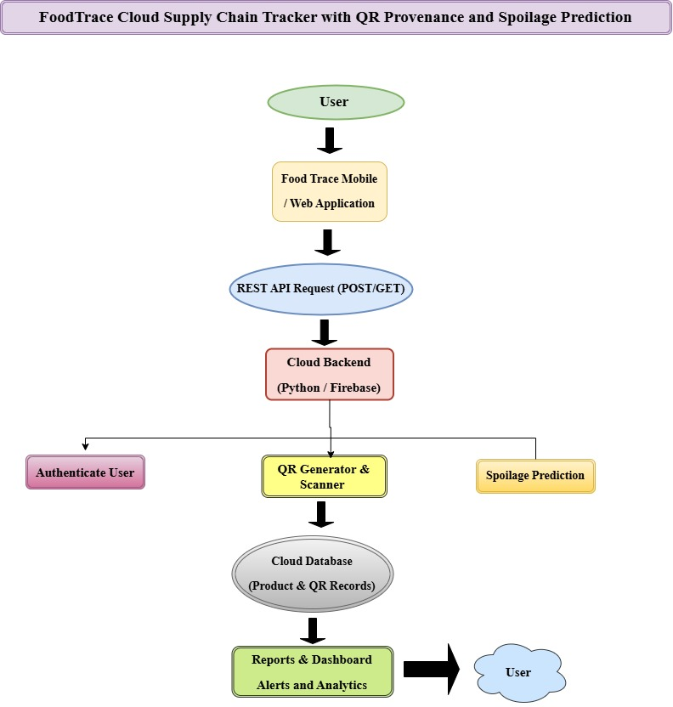

Brief explanation: explain one complete request-response path from user action to cloud response.
The user logs into the FoodTrace application and submits product information. The request is sent through a REST API to the cloud backend. The backend authenticates the user, generates or scans the QR code, and performs spoilage prediction. The processed data is stored in the cloud database. Finally, the system displays reports, analytics, and alerts on the dashboard. Cloud security protects user data, while scalability allows the application to support many users simultaneously.

Task 4 - Individual Reflection
Answer the following from your own perspective. Avoid team-common wording.
- What is the strongest cloud concept represented in your capstone project?
The strongest cloud concept in my project is scalability. It allows the FoodTrace system to handle many users and store large amounts of product data efficiently.

- Where will elasticity or scalability become important in your capstone product?
Elasticity and scalability become important when many suppliers, retailers, and customers access the application at the same time. The cloud automatically increases or decreases resources based on user demand.

- Which API or web-service idea is most relevant to your project and why?
The REST API is the most relevant because it enables communication between the FoodTrace application, cloud server, QR code service, and cloud database. It allows fast and secure data exchange.

- What did you personally understand better after preparing this concept map and matrix?
I understood how IaaS, PaaS, SaaS, REST APIs, cloud storage, scalability, and virtualization work together to build a secure and efficient cloud-based application. I also learned how cloud services improve food traceability and real-time monitoring.

Evaluation Rubric - 100 Marks
Criteria | Marks | Expected Standard
Concept identification | 20 | Major CO1 concepts are accurately identified: cloud fundamentals, characteristics, evolution, service models, deployment models, virtualization, web services, SOAP/REST, APIs, elasticity, and scalability.
Relationship mapping | 20 | Links between concepts are accurate, meaningful, and labeled. The map should explain how concepts depend on, enable, consume, provide, scale, or control one another.
Hierarchy and organization | 15 | Concepts are arranged in a logical hierarchy with clear grouping, readable flow, and no disconnected keyword clusters.
Technical relevance | 15 | The map strongly reflects cloud course content and avoids decorative or generic non-technical content.
Service model matrix | 15 | IaaS, PaaS, SaaS, and XaaS are compared with provider responsibility, user responsibility, examples, capstone usage, and risks or limitations.
Capstone alignment and individual reflection | 10 | The student's own capstone interpretation is visible in the concept map, flow mapping, justification, and reflection. Team-common answers are avoided.
Visual clarity and digital evidence | 5 | Diagram is neat, readable, exported properly, and supported with GitHub evidence including source and exported files.

Faculty Evaluation Record
Evaluator Name |  | Marks Awarded
Observation |  | Signature

